School of Computer Science and Mathematics

Data Structures and Algorithms (SP2)

Student (Last Name, First Name): Pocz, Bartosz
Assignment 7. Hashing and Hash Table
(Use in solution your own class Hash Table with Linked List)
- Check for Duplicates
  - Given an array of n integers, determine if any integer appears more than once.
  - Example:
    - Input: [1, 2, 3, 4, 5, 1]
    - Output: true (since 1 appears twice)
- Find the First Non-Repeating Character
  - Given a string, find the first non-repeating character using hashing.
  - Example:
    - Input: "aabbcddee"
    - Output: 'c' (since c appears only once and is the first unique character)
- Count Frequency of Elements
  - Given an array, return a dictionary (hash table) where keys are unique numbers and values are their frequencies.
  - Example:
    - Input: [4, 5, 6, 5, 4, 6, 6]
    - Output: {4: 2, 5: 2, 6: 3}
- Find Pairs with Given Sum
  - Given an array of numbers and a target sum, find all pairs of numbers that add up to the sum.
  - Example:
    - Input: arr = [1, 2, 3, 4, 5, 6], target = 7
    - Output: [(1,6), (2,5), (3,4)]
5. Find the Most Frequent Element
- Given an array of integers, find the element that appears the most times. If multiple elements have the same highest frequency, return any of them.
- Example:
  - Input: [1, 3, 2, 3, 4, 3, 5, 2, 2]
  - Output: 3 (since 3 appears the most times)
6. Check if Two Strings are Isomorphic
- Two strings are isomorphic if the characters in one string can be replaced to get the second string while preserving order.
- Example:
  - Input: s = "egg", t = "add"
  - Output: true
  - Input: s = "foo", t = "bar"
  - Output: false
7. Find First Repeating Element
- Given an array, find the first element that appears more than once, scanning from left to right.
- Example:
  - Input: [3, 5, 4, 3, 5, 6]
  - Output: 3
8. Check if a Word is Formed by Concatenating Other Words
- Given a dictionary of words and a target word, check if the target word can be formed by concatenating two words from the dictionary.
- Example:
  - Input: words = ["hello", "world", "helloworld"], target = "helloworld"
  - Output: true
9. Find Common Elements in Three Sorted Arrays
- Given three sorted arrays, find the elements that appear in all three arrays.
- Example:
  - Input: [1, 5, 10, 20], [5, 10, 15, 20], [5, 20, 30, 40]
  - Output: [5, 20]
10. Find Intersection of Two Arrays
  - Given two unsorted arrays, find the common elements using hashing.
  - Example:
    - Input: arr1 = [1, 2, 3, 4, 5], arr2 = [3, 4, 5, 6, 7]
    - Output: [3, 4, 5]
11. Find the Subarray with Sum Zero
  - Given an array of integers, check if there exists a subarray with a sum of zero.
  - Example:
    - Input: [4, 2, -3, 1, 6]
    - Output: true (because 2 + (-3) + 1 = 0)
12. Find the Longest Consecutive Sequence
  - Given an unsorted array, find the length of the longest consecutive sequence of numbers.
  - Example:
    - Input: [100, 4, 200, 1, 3, 2]
    - Output: 4 (since [1, 2, 3, 4] is the longest sequence)
13. Check if Two Strings are Anagrams
- Given two strings, check if they are anagrams (contain the same characters with the same frequency).
- Example:
  - Input: "listen", "silent"
  - Output: true
14. Find Pairs with Given XOR Value
- Given an array of numbers, count how many pairs (a, b) exist such that a XOR b equals a given value k.
- Example:
  - Input: arr = [5, 6, 7, 8, 9], k = 1
  - Output: 2
15. Find All Anagrams in a String
- Given two strings s and p, find all the start indices of p's anagrams in s.
- Return the answer in any order.
- An anagram of a string is another string that contains the same characters with the same frequencies, but possibly in a different order.
- You must solve this using hashing (e.g., character frequency maps) and a sliding window approach.
- Example:
  - s = "cbaebabacd"
  - p = "abc"
  - Output: [0, 6]
  - Explanation: "ab" at 0, "ba" at 1, "ab" at 2 — all are anagrams of "ab".

Submission Guidelines:
- Submit your Report with solution source codes as text.
- Clearly label each exercise in your submission.
- Exercises are due at the beginning of the next class.
- Solution codes has to be with full screenshots of code run result!
- Finally, whole Assignment Report upload on Moodle!
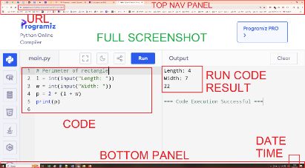

// C++ version -------------------------------------------------------------------------
#include <iostream>

#define TABLE_SIZE 10 // Size of the hash table

using namespace std;

class Node {
public:
int key, value;
Node* next;
Node(int k, int v) : key(k), value(v), next(nullptr) {}
};

class LinkedList {
public:
Node* head;
LinkedList() : head(nullptr) {}

void insert(int key, int value) {
Node* newNode = new Node(key, value);
newNode->next = head;
head = newNode;
}

int search(int key) {
Node* temp = head;
while (temp) {
if (temp->key == key) return temp->value;
temp = temp->next;
}
return -1; // Key not found
}

void remove(int key) {
Node* temp = head;
Node* prev = nullptr;
while (temp) {
if (temp->key == key) {
if (prev) prev->next = temp->next;
else head = temp->next;
delete temp;
return;
}
prev = temp;
temp = temp->next;
}
cout << "Key not found!" << endl;
}

void display() {
Node* temp = head;
while (temp) {
cout << " -> (" << temp->key << ", " << temp->value << ")";
temp = temp->next;
}
}
};

class HashTable {
private:
LinkedList table[TABLE_SIZE]; // Array of linked lists for chaining

int hashFunction(int key) {
return key % TABLE_SIZE;
}

public:
void insert(int key, int value) {
int index = hashFunction(key);
table[index].insert(key, value);
}

int search(int key) {
int index = hashFunction(key);
return table[index].search(key);
}

void remove(int key) {
int index = hashFunction(key);
table[index].remove(key);
}

void display() {
for (int i = 0; i < TABLE_SIZE; i++) {
cout << "Index " << i << ":";
table[i].display();
cout << endl;
}
}
};

int main() {
HashTable ht;
ht.insert(5, 50);
ht.insert(15, 150);
ht.insert(25, 250);
ht.insert(35, 350);
ht.insert(10, 100);

ht.display();

cout << "Searching for key 15: " << ht.search(15) << endl;
cout << "Searching for key 100: " << ht.search(100) << endl;

ht.remove(15);
cout << "After removing key 15:" << endl;
ht.display();

return 0;
}

# PYTHON version -------------------------------------------------------------------------

TABLE_SIZE = 10 # Size of the hash table

class Node:
def __init__(self, key, value):
self.key = key
self.value = value
self.next = None

class LinkedList:
def __init__(self):
self.head = None

def insert(self, key, value):
new_node = Node(key, value)
new_node.next = self.head
self.head = new_node

def search(self, key):
temp = self.head
while temp:
if temp.key == key:
return temp.value
temp = temp.next
return -1 # Key not found

def remove(self, key):
temp = self.head
prev = None
while temp:
if temp.key == key:
if prev:
prev.next = temp.next
else:
self.head = temp.next
return # Node removed
prev = temp
temp = temp.next
print("Key not found!")

def display(self):
temp = self.head
while temp:
print(f" -> ({temp.key}, {temp.value})", end="")
temp = temp.next

class HashTable:
def __init__(self):
self.table = [LinkedList() for _ in range(TABLE_SIZE)]

def hash_function(self, key):
return key % TABLE_SIZE

def insert(self, key, value):
index = self.hash_function(key)
self.table[index].insert(key, value)

def search(self, key):
index = self.hash_function(key)
return self.table[index].search(key)

def remove(self, key):
index = self.hash_function(key)
self.table[index].remove(key)

def display(self):
for i in range(TABLE_SIZE):
print(f"Index {i}:", end="")
self.table[i].display()
print()

# --- main ---
if __name__ == "__main__":
ht = HashTable()
ht.insert(5, 50)
ht.insert(15, 150)
ht.insert(25, 250)
ht.insert(35, 350)
ht.insert(10, 100)

ht.display()

print("Searching for key 15:", ht.search(15))
print("Searching for key 100:", ht.search(100))

ht.remove(15)
print("After removing key 15:")
ht.display()
Completed Solutions
Exercise 1
Code (ex1.cpp):
#include <functional>
#include <iostream>
#include <utility>
#include <vector>

using namespace std;

template <typename K, typename V>
class HashTable {
private:
struct Node {
K key;
V value;
Node* next;

Node(const K& newKey, const V& newValue) : key(newKey), value(newValue), next(nullptr) {}
};

vector<Node*> buckets;

size_t hashIndex(const K& key) const {
return hash<K>{}(key) % buckets.size();
}

public:
explicit HashTable(size_t bucketCount = 211) : buckets(bucketCount, nullptr) {}

~HashTable() {
clear();
}

void clear() {
for (Node*& head : buckets) {
while (head != nullptr) {
Node* next = head->next;
delete head;
head = next;
}
}
}

bool contains(const K& key) const {
size_t index = hashIndex(key);
Node* current = buckets[index];
while (current != nullptr) {
if (current->key == key) {
return true;
}
current = current->next;
}
return false;
}

void insert(const K& key, const V& value) {
size_t index = hashIndex(key);
Node* current = buckets[index];
while (current != nullptr) {
if (current->key == key) {
current->value = value;
return;
}
current = current->next;
}

Node* node = new Node(key, value);
node->next = buckets[index];
buckets[index] = node;
}
};

bool hasDuplicates(const vector<int>& numbers) {
HashTable<int, bool> seen;

for (int number : numbers) {
if (seen.contains(number)) {
return true;
}
seen.insert(number, true);
}

return false;
}

int main() {
int n;
cout << "Enter the number of integers: ";
cin >> n;

vector<int> numbers(n);
cout << "Enter " << n << " integers: ";
for (int i = 0; i < n; ++i) {
cin >> numbers[i];
}

cout << "Duplicate exists: " << (hasDuplicates(numbers) ? "true" : "false") << '\n';
return 0;
}
Screenshot:
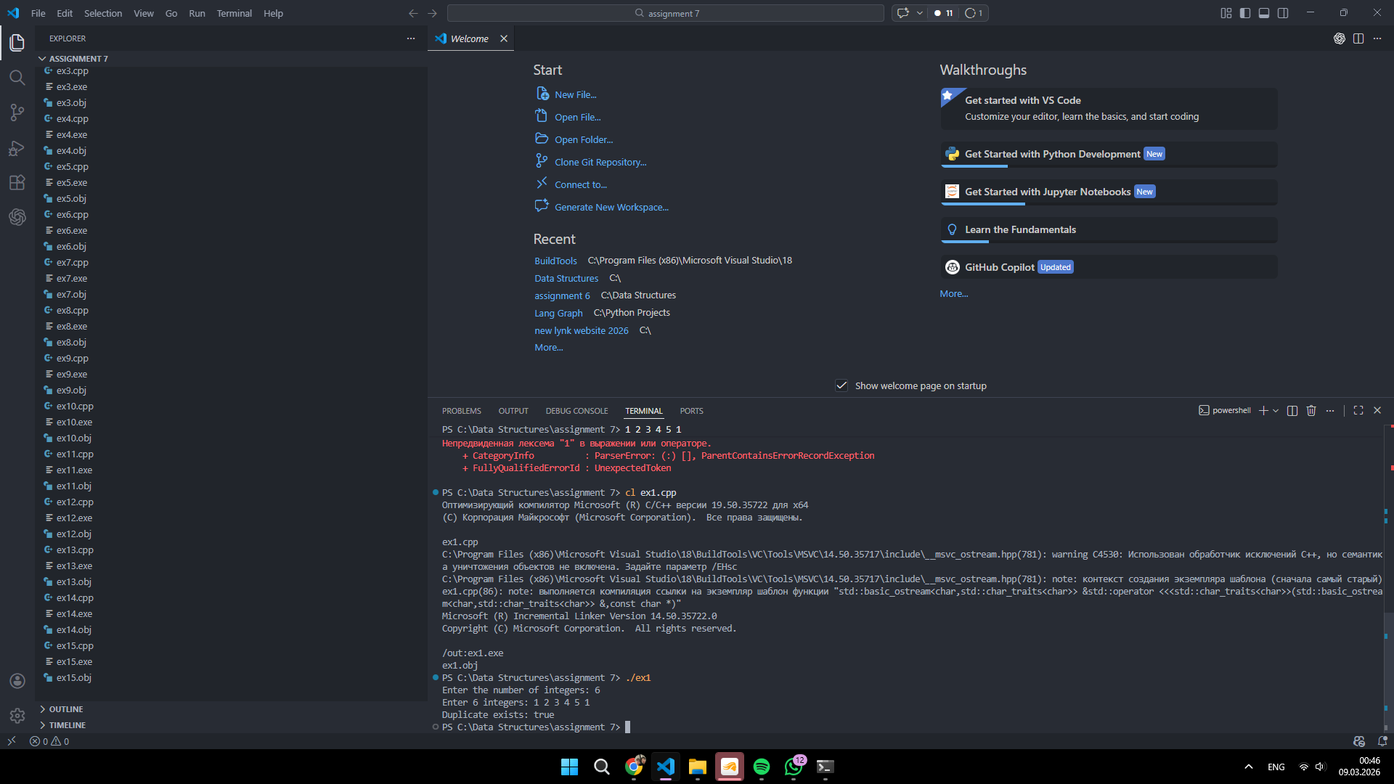
Exercise 2
Code (ex2.cpp):
#include <functional>
#include <iostream>
#include <string>
#include <utility>
#include <vector>

using namespace std;

template <typename K, typename V>
class HashTable {
private:
struct Node {
K key;
V value;
Node* next;

Node(const K& newKey, const V& newValue) : key(newKey), value(newValue), next(nullptr) {}
};

vector<Node*> buckets;

size_t hashIndex(const K& key) const {
return hash<K>{}(key) % buckets.size();
}

public:
explicit HashTable(size_t bucketCount = 211) : buckets(bucketCount, nullptr) {}

~HashTable() {
clear();
}

void clear() {
for (Node*& head : buckets) {
while (head != nullptr) {
Node* next = head->next;
delete head;
head = next;
}
}
}

V getOrDefault(const K& key, const V& defaultValue) const {
size_t index = hashIndex(key);
Node* current = buckets[index];
while (current != nullptr) {
if (current->key == key) {
return current->value;
}
current = current->next;
}
return defaultValue;
}

void insert(const K& key, const V& value) {
size_t index = hashIndex(key);
Node* current = buckets[index];
while (current != nullptr) {
if (current->key == key) {
current->value = value;
return;
}
current = current->next;
}

Node* node = new Node(key, value);
node->next = buckets[index];
buckets[index] = node;
}
};

char firstNonRepeatingCharacter(const string& text) {
HashTable<char, int> frequencies;

for (char ch : text) {
frequencies.insert(ch, frequencies.getOrDefault(ch, 0) + 1);
}

for (char ch : text) {
if (frequencies.getOrDefault(ch, 0) == 1) {
return ch;
}
}

return '\0';
}

int main() {
string text;
cout << "Enter a string without spaces: ";
cin >> text;

char result = firstNonRepeatingCharacter(text);
if (result == '\0') {
cout << "First non-repeating character: none\n";
} else {
cout << "First non-repeating character: " << result << '\n';
}

return 0;
}
Screenshot:
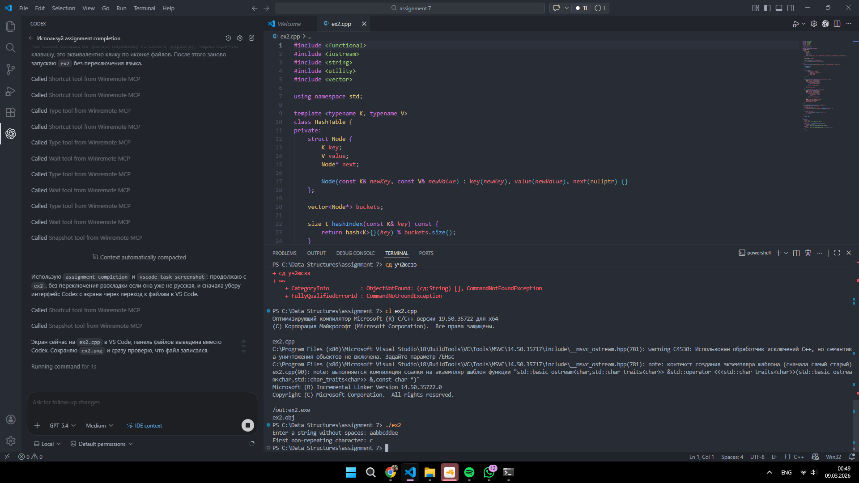
Exercise 3
Code (ex3.cpp):
#include <algorithm>
#include <functional>
#include <iostream>
#include <utility>
#include <vector>

using namespace std;

template <typename K, typename V>
class HashTable {
private:
struct Node {
K key;
V value;
Node* next;

Node(const K& newKey, const V& newValue) : key(newKey), value(newValue), next(nullptr) {}
};

vector<Node*> buckets;

size_t hashIndex(const K& key) const {
return hash<K>{}(key) % buckets.size();
}

public:
explicit HashTable(size_t bucketCount = 211) : buckets(bucketCount, nullptr) {}

~HashTable() {
clear();
}

void clear() {
for (Node*& head : buckets) {
while (head != nullptr) {
Node* next = head->next;
delete head;
head = next;
}
}
}

V getOrDefault(const K& key, const V& defaultValue) const {
size_t index = hashIndex(key);
Node* current = buckets[index];
while (current != nullptr) {
if (current->key == key) {
return current->value;
}
current = current->next;
}
return defaultValue;
}

void insert(const K& key, const V& value) {
size_t index = hashIndex(key);
Node* current = buckets[index];
while (current != nullptr) {
if (current->key == key) {
current->value = value;
return;
}
current = current->next;
}

Node* node = new Node(key, value);
node->next = buckets[index];
buckets[index] = node;
}

vector<pair<K, V>> items() const {
vector<pair<K, V>> result;
for (Node* head : buckets) {
Node* current = head;
while (current != nullptr) {
result.push_back(make_pair(current->key, current->value));
current = current->next;
}
}
return result;
}
};

int main() {
int n;
cout << "Enter the number of integers: ";
cin >> n;

vector<int> numbers(n);
cout << "Enter " << n << " integers: ";
for (int i = 0; i < n; ++i) {
cin >> numbers[i];
}

HashTable<int, int> frequencies;
for (int number : numbers) {
frequencies.insert(number, frequencies.getOrDefault(number, 0) + 1);
}
vector<pair<int, int>> items = frequencies.items();
sort(items.begin(), items.end());

cout << "Frequencies: {";
for (size_t i = 0; i < items.size(); ++i) {
cout << items[i].first << ": " << items[i].second;
if (i + 1 != items.size()) {
cout << ", ";
}
}
cout << "}\n";

return 0;
}
Screenshot:
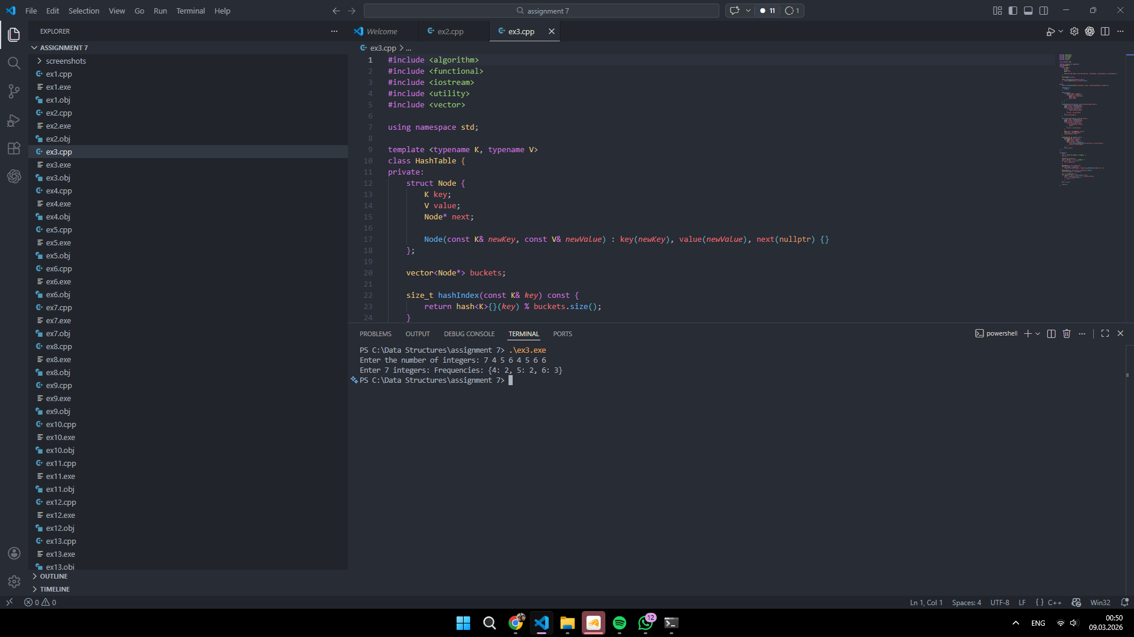
Exercise 4
Code (ex4.cpp):
#include <algorithm>
#include <functional>
#include <iostream>
#include <string>
#include <utility>
#include <vector>

using namespace std;

template <typename K, typename V>
class HashTable {
private:
struct Node {
K key;
V value;
Node* next;

Node(const K& newKey, const V& newValue) : key(newKey), value(newValue), next(nullptr) {}
};

vector<Node*> buckets;

size_t hashIndex(const K& key) const {
return hash<K>{}(key) % buckets.size();
}

public:
explicit HashTable(size_t bucketCount = 211) : buckets(bucketCount, nullptr) {}

~HashTable() {
clear();
}

void clear() {
for (Node*& head : buckets) {
while (head != nullptr) {
Node* next = head->next;
delete head;
head = next;
}
}
}

bool contains(const K& key) const {
size_t index = hashIndex(key);
Node* current = buckets[index];
while (current != nullptr) {
if (current->key == key) {
return true;
}
current = current->next;
}
return false;
}

void insert(const K& key, const V& value) {
size_t index = hashIndex(key);
Node* current = buckets[index];
while (current != nullptr) {
if (current->key == key) {
current->value = value;
return;
}
current = current->next;
}

Node* node = new Node(key, value);
node->next = buckets[index];
buckets[index] = node;
}
};

vector<pair<int, int>> findPairsWithSum(const vector<int>& numbers, int target) {
HashTable<int, bool> seen;
HashTable<string, bool> addedPairs;
vector<pair<int, int>> pairs;

for (int number : numbers) {
int needed = target - number;
if (seen.contains(needed)) {
int left = min(number, needed);
int right = max(number, needed);
string key = to_string(left) + "#" + to_string(right);
if (!addedPairs.contains(key)) {
pairs.push_back(make_pair(left, right));
addedPairs.insert(key, true);
}
}
seen.insert(number, true);
}

sort(pairs.begin(), pairs.end());
return pairs;
}

int main() {
int n;
cout << "Enter the number of integers: ";
cin >> n;

vector<int> numbers(n);
cout << "Enter " << n << " integers: ";
for (int i = 0; i < n; ++i) {
cin >> numbers[i];
}

int target;
cout << "Enter the target sum: ";
cin >> target;

vector<pair<int, int>> pairs = findPairsWithSum(numbers, target);
cout << "Pairs: [";
for (size_t i = 0; i < pairs.size(); ++i) {
cout << "(" << pairs[i].first << ", " << pairs[i].second << ")";
if (i + 1 != pairs.size()) {
cout << ", ";
}
}
cout << "]\n";

return 0;
}
Screenshot:
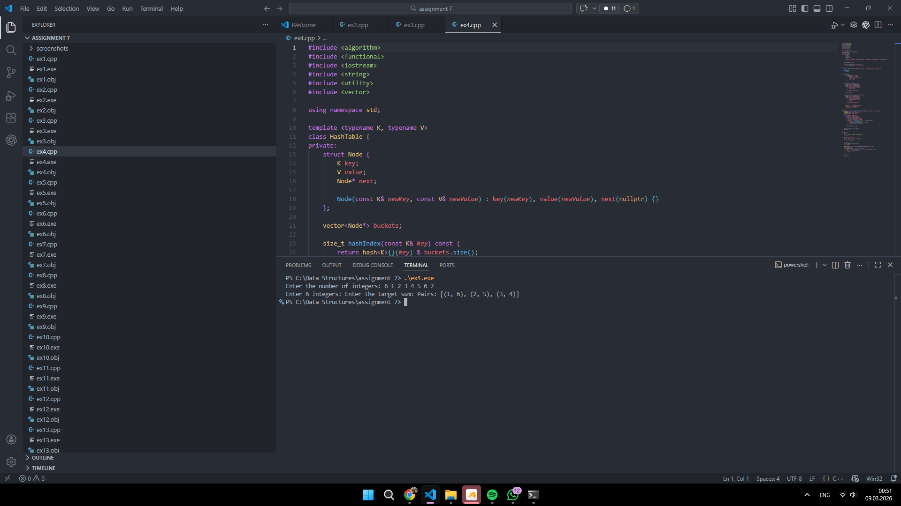
Exercise 5
Code (ex5.cpp):
#include <functional>
#include <iostream>
#include <utility>
#include <vector>

using namespace std;

template <typename K, typename V>
class HashTable {
private:
struct Node {
K key;
V value;
Node* next;

Node(const K& newKey, const V& newValue) : key(newKey), value(newValue), next(nullptr) {}
};

vector<Node*> buckets;

size_t hashIndex(const K& key) const {
return hash<K>{}(key) % buckets.size();
}

public:
explicit HashTable(size_t bucketCount = 211) : buckets(bucketCount, nullptr) {}

~HashTable() {
clear();
}

void clear() {
for (Node*& head : buckets) {
while (head != nullptr) {
Node* next = head->next;
delete head;
head = next;
}
}
}

V getOrDefault(const K& key, const V& defaultValue) const {
size_t index = hashIndex(key);
Node* current = buckets[index];
while (current != nullptr) {
if (current->key == key) {
return current->value;
}
current = current->next;
}
return defaultValue;
}

void insert(const K& key, const V& value) {
size_t index = hashIndex(key);
Node* current = buckets[index];
while (current != nullptr) {
if (current->key == key) {
current->value = value;
return;
}
current = current->next;
}

Node* node = new Node(key, value);
node->next = buckets[index];
buckets[index] = node;
}

vector<pair<K, V>> items() const {
vector<pair<K, V>> result;
for (Node* head : buckets) {
Node* current = head;
while (current != nullptr) {
result.push_back(make_pair(current->key, current->value));
current = current->next;
}
}
return result;
}
};

int mostFrequentElement(const vector<int>& numbers) {
HashTable<int, int> frequencies;
int bestValue = numbers[0];
int bestFrequency = 0;

for (int number : numbers) {
int frequency = frequencies.getOrDefault(number, 0) + 1;
frequencies.insert(number, frequency);
if (frequency > bestFrequency) {
bestFrequency = frequency;
bestValue = number;
}
}

return bestValue;
}

int main() {
int n;
cout << "Enter the number of integers: ";
cin >> n;

vector<int> numbers(n);
cout << "Enter " << n << " integers: ";
for (int i = 0; i < n; ++i) {
cin >> numbers[i];
}

cout << "Most frequent element: " << mostFrequentElement(numbers) << '\n';
return 0;
}
Screenshot:
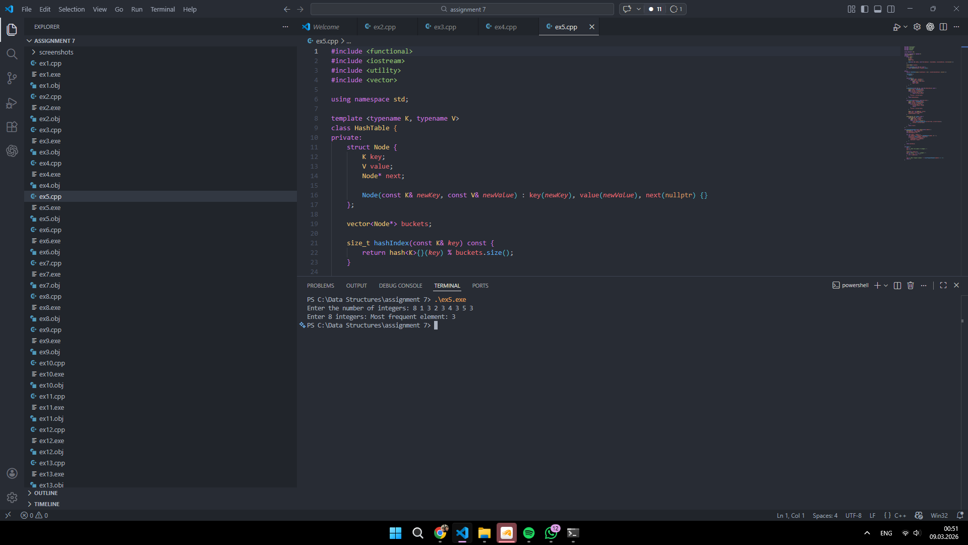
Exercise 6
Code (ex6.cpp):
#include <functional>
#include <iostream>
#include <string>
#include <utility>
#include <vector>

using namespace std;

template <typename K, typename V>
class HashTable {
private:
struct Node {
K key;
V value;
Node* next;

Node(const K& newKey, const V& newValue) : key(newKey), value(newValue), next(nullptr) {}
};

vector<Node*> buckets;

size_t hashIndex(const K& key) const {
return hash<K>{}(key) % buckets.size();
}

public:
explicit HashTable(size_t bucketCount = 211) : buckets(bucketCount, nullptr) {}

~HashTable() {
clear();
}

void clear() {
for (Node*& head : buckets) {
while (head != nullptr) {
Node* next = head->next;
delete head;
head = next;
}
}
}

bool contains(const K& key) const {
size_t index = hashIndex(key);
Node* current = buckets[index];
while (current != nullptr) {
if (current->key == key) {
return true;
}
current = current->next;
}
return false;
}

V getOrDefault(const K& key, const V& defaultValue) const {
size_t index = hashIndex(key);
Node* current = buckets[index];
while (current != nullptr) {
if (current->key == key) {
return current->value;
}
current = current->next;
}
return defaultValue;
}

void insert(const K& key, const V& value) {
size_t index = hashIndex(key);
Node* current = buckets[index];
while (current != nullptr) {
if (current->key == key) {
current->value = value;
return;
}
current = current->next;
}

Node* node = new Node(key, value);
node->next = buckets[index];
buckets[index] = node;
}
};

bool areIsomorphic(const string& first, const string& second) {
if (first.length() != second.length()) {
return false;
}

HashTable<char, char> leftToRight;
HashTable<char, char> rightToLeft;

for (size_t i = 0; i < first.length(); ++i) {
char left = first[i];
char right = second[i];

if (leftToRight.contains(left) && leftToRight.getOrDefault(left, '\0') != right) {
return false;
}
if (rightToLeft.contains(right) && rightToLeft.getOrDefault(right, '\0') != left) {
return false;
}

leftToRight.insert(left, right);
rightToLeft.insert(right, left);
}

return true;
}

int main() {
string first;
string second;

cout << "Enter the first string without spaces: ";
cin >> first;
cout << "Enter the second string without spaces: ";
cin >> second;

cout << "Isomorphic: " << (areIsomorphic(first, second) ? "true" : "false") << '\n';
return 0;
}
Screenshot:
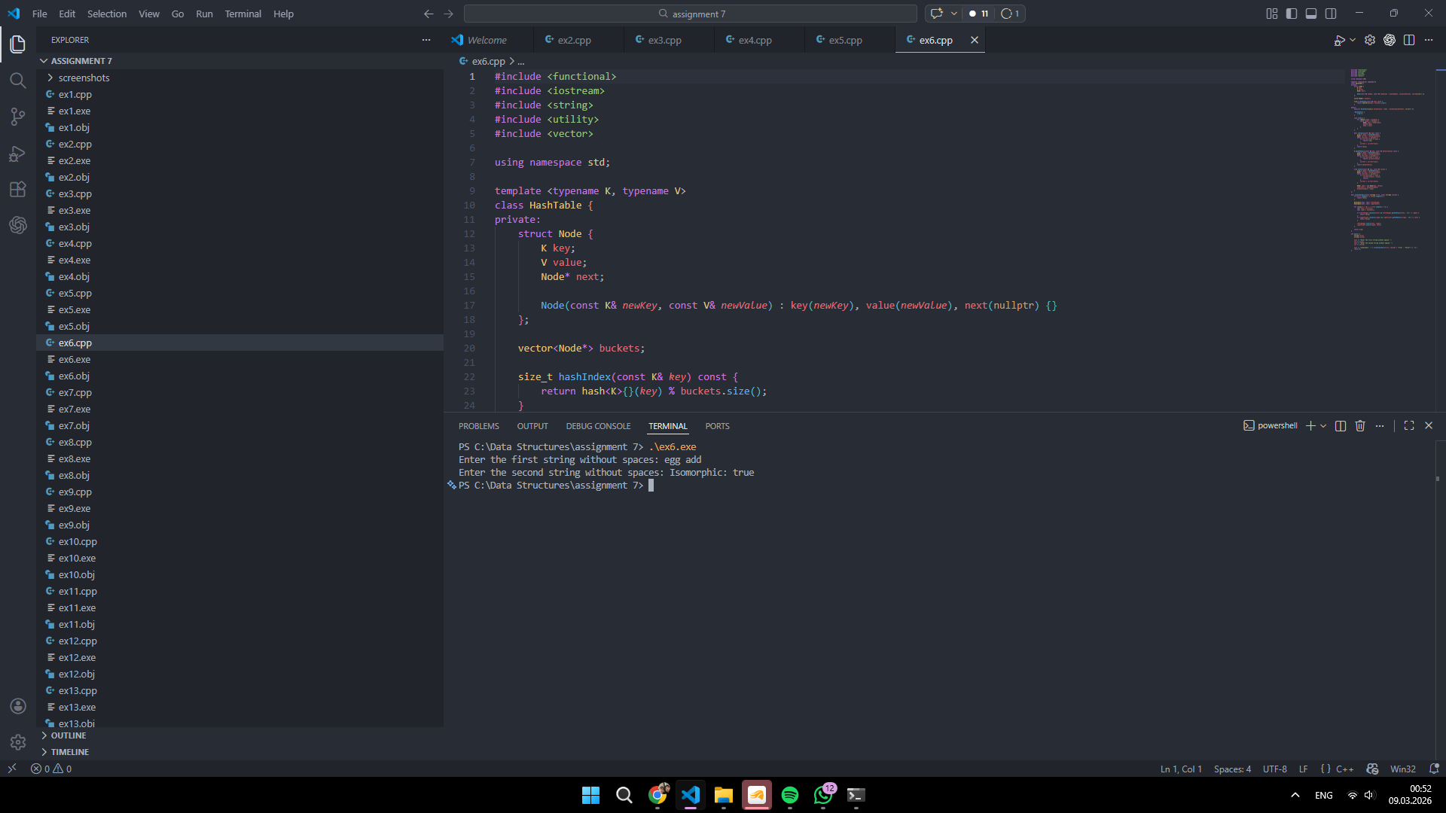
Exercise 7
Code (ex7.cpp):
#include <functional>
#include <iostream>
#include <utility>
#include <vector>

using namespace std;

template <typename K, typename V>
class HashTable {
private:
struct Node {
K key;
V value;
Node* next;

Node(const K& newKey, const V& newValue) : key(newKey), value(newValue), next(nullptr) {}
};

vector<Node*> buckets;

size_t hashIndex(const K& key) const {
return hash<K>{}(key) % buckets.size();
}

public:
explicit HashTable(size_t bucketCount = 211) : buckets(bucketCount, nullptr) {}

~HashTable() {
clear();
}

void clear() {
for (Node*& head : buckets) {
while (head != nullptr) {
Node* next = head->next;
delete head;
head = next;
}
}
}

bool contains(const K& key) const {
size_t index = hashIndex(key);
Node* current = buckets[index];
while (current != nullptr) {
if (current->key == key) {
return true;
}
current = current->next;
}
return false;
}

void insert(const K& key, const V& value) {
size_t index = hashIndex(key);
Node* current = buckets[index];
while (current != nullptr) {
if (current->key == key) {
current->value = value;
return;
}
current = current->next;
}

Node* node = new Node(key, value);
node->next = buckets[index];
buckets[index] = node;
}
};

int firstRepeatingElement(const vector<int>& numbers) {
HashTable<int, bool> seen;

for (int number : numbers) {
if (seen.contains(number)) {
return number;
}
seen.insert(number, true);
}

return -1;
}

int main() {
int n;
cout << "Enter the number of integers: ";
cin >> n;

vector<int> numbers(n);
cout << "Enter " << n << " integers: ";
for (int i = 0; i < n; ++i) {
cin >> numbers[i];
}

int result = firstRepeatingElement(numbers);
if (result == -1) {
cout << "First repeating element: none\n";
} else {
cout << "First repeating element: " << result << '\n';
}

return 0;
}
Screenshot:
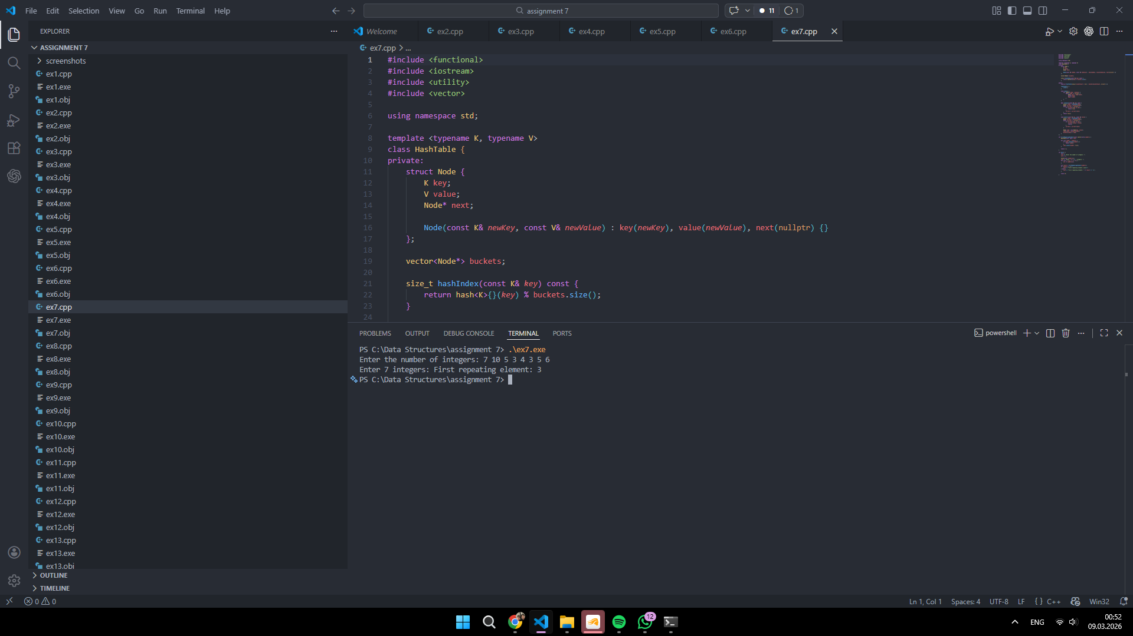
Exercise 8
Code (ex8.cpp):
#include <functional>
#include <iostream>
#include <string>
#include <utility>
#include <vector>

using namespace std;

template <typename K, typename V>
class HashTable {
private:
struct Node {
K key;
V value;
Node* next;

Node(const K& newKey, const V& newValue) : key(newKey), value(newValue), next(nullptr) {}
};

vector<Node*> buckets;

size_t hashIndex(const K& key) const {
return hash<K>{}(key) % buckets.size();
}

public:
explicit HashTable(size_t bucketCount = 211) : buckets(bucketCount, nullptr) {}

~HashTable() {
clear();
}

void clear() {
for (Node*& head : buckets) {
while (head != nullptr) {
Node* next = head->next;
delete head;
head = next;
}
}
}

bool contains(const K& key) const {
size_t index = hashIndex(key);
Node* current = buckets[index];
while (current != nullptr) {
if (current->key == key) {
return true;
}
current = current->next;
}
return false;
}

V getOrDefault(const K& key, const V& defaultValue) const {
size_t index = hashIndex(key);
Node* current = buckets[index];
while (current != nullptr) {
if (current->key == key) {
return current->value;
}
current = current->next;
}
return defaultValue;
}

void insert(const K& key, const V& value) {
size_t index = hashIndex(key);
Node* current = buckets[index];
while (current != nullptr) {
if (current->key == key) {
current->value = value;
return;
}
current = current->next;
}

Node* node = new Node(key, value);
node->next = buckets[index];
buckets[index] = node;
}
};

bool canBeFormedByTwoWords(const vector<string>& words, const string& target) {
HashTable<string, int> frequencies;
for (const string& word : words) {
frequencies.insert(word, frequencies.getOrDefault(word, 0) + 1);
}

for (size_t i = 1; i < target.length(); ++i) {
string left = target.substr(0, i);
string right = target.substr(i);

if (!frequencies.contains(left) || !frequencies.contains(right)) {
continue;
}

if (left != right || frequencies.getOrDefault(left, 0) >= 2) {
return true;
}
}

return false;
}

int main() {
int n;
cout << "Enter the number of dictionary words: ";
cin >> n;

vector<string> words(n);
cout << "Enter " << n << " words: ";
for (int i = 0; i < n; ++i) {
cin >> words[i];
}

string target;
cout << "Enter the target word: ";
cin >> target;

cout << "Can be formed by concatenating two words: "
<< (canBeFormedByTwoWords(words, target) ? "true" : "false") << '\n';
return 0;
}
Screenshot:
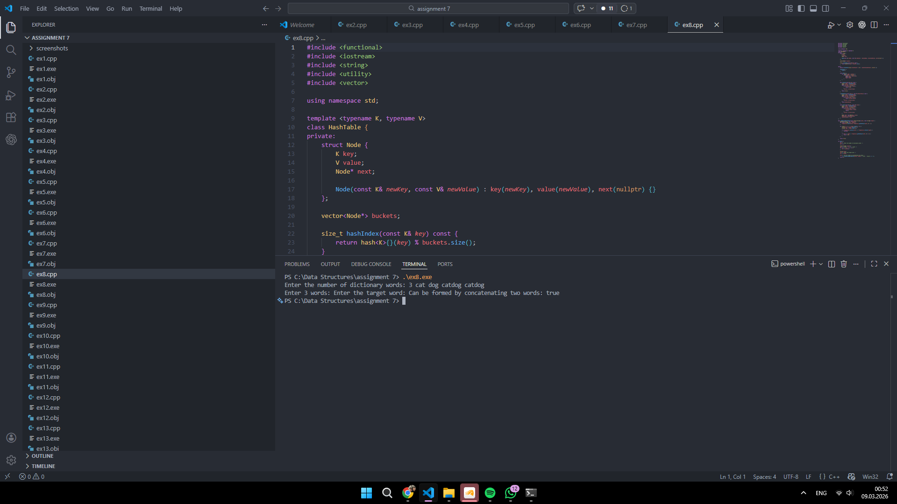
Exercise 9
Code (ex9.cpp):
#include <algorithm>
#include <functional>
#include <iostream>
#include <utility>
#include <vector>

using namespace std;

template <typename K, typename V>
class HashTable {
private:
struct Node {
K key;
V value;
Node* next;

Node(const K& newKey, const V& newValue) : key(newKey), value(newValue), next(nullptr) {}
};

vector<Node*> buckets;

size_t hashIndex(const K& key) const {
return hash<K>{}(key) % buckets.size();
}

public:
explicit HashTable(size_t bucketCount = 211) : buckets(bucketCount, nullptr) {}

~HashTable() {
clear();
}

void clear() {
for (Node*& head : buckets) {
while (head != nullptr) {
Node* next = head->next;
delete head;
head = next;
}
}
}

bool contains(const K& key) const {
size_t index = hashIndex(key);
Node* current = buckets[index];
while (current != nullptr) {
if (current->key == key) {
return true;
}
current = current->next;
}
return false;
}

void insert(const K& key, const V& value) {
size_t index = hashIndex(key);
Node* current = buckets[index];
while (current != nullptr) {
if (current->key == key) {
current->value = value;
return;
}
current = current->next;
}

Node* node = new Node(key, value);
node->next = buckets[index];
buckets[index] = node;
}
};

vector<int> commonElements(const vector<int>& first, const vector<int>& second, const vector<int>& third) {
HashTable<int, bool> inFirst;
HashTable<int, bool> inSecond;
HashTable<int, bool> added;
vector<int> result;

for (int value : first) {
inFirst.insert(value, true);
}
for (int value : second) {
inSecond.insert(value, true);
}

for (int value : third) {
if (inFirst.contains(value) && inSecond.contains(value) && !added.contains(value)) {
result.push_back(value);
added.insert(value, true);
}
}

sort(result.begin(), result.end());
return result;
}

int main() {
int n1;
cout << "Enter the size of the first sorted array: ";
cin >> n1;
vector<int> first(n1);
cout << "Enter " << n1 << " integers for the first array: ";
for (int i = 0; i < n1; ++i) {
cin >> first[i];
}

int n2;
cout << "Enter the size of the second sorted array: ";
cin >> n2;
vector<int> second(n2);
cout << "Enter " << n2 << " integers for the second array: ";
for (int i = 0; i < n2; ++i) {
cin >> second[i];
}

int n3;
cout << "Enter the size of the third sorted array: ";
cin >> n3;
vector<int> third(n3);
cout << "Enter " << n3 << " integers for the third array: ";
for (int i = 0; i < n3; ++i) {
cin >> third[i];
}

vector<int> result = commonElements(first, second, third);
cout << "Common elements: [";
for (size_t i = 0; i < result.size(); ++i) {
cout << result[i];
if (i + 1 != result.size()) {
cout << ", ";
}
}
cout << "]\n";

return 0;
}
Screenshot:
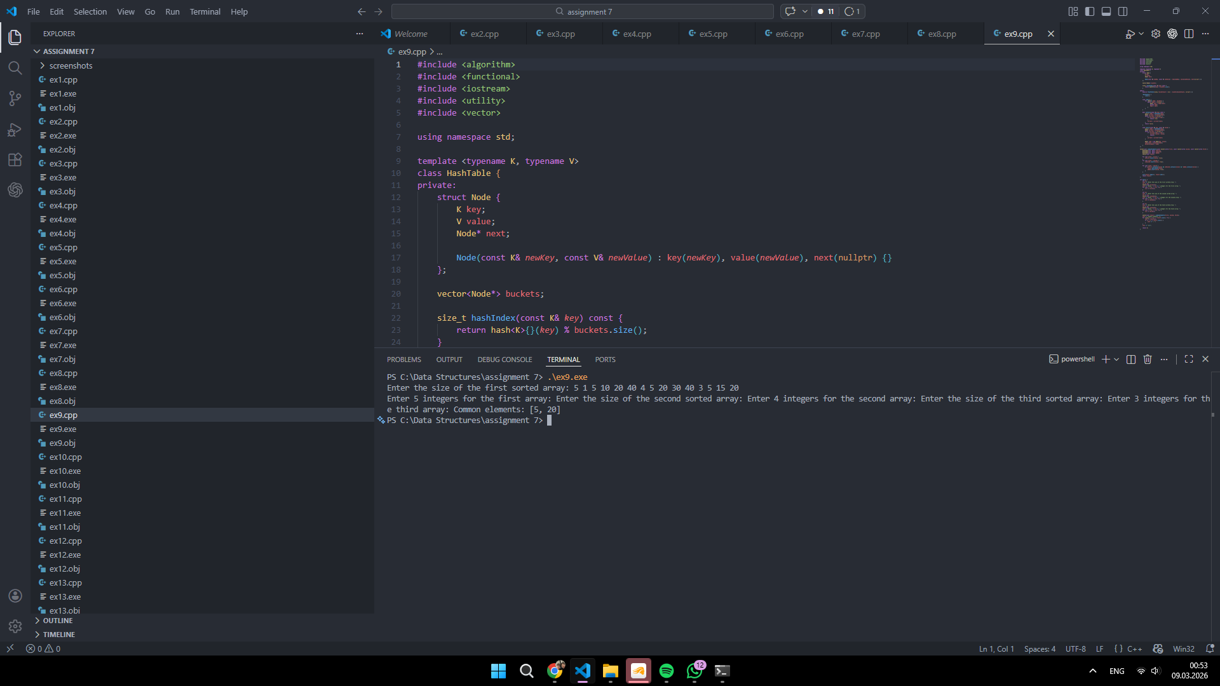
Exercise 10
Code (ex10.cpp):
#include <algorithm>
#include <functional>
#include <iostream>
#include <utility>
#include <vector>

using namespace std;

template <typename K, typename V>
class HashTable {
private:
struct Node {
K key;
V value;
Node* next;

Node(const K& newKey, const V& newValue) : key(newKey), value(newValue), next(nullptr) {}
};

vector<Node*> buckets;

size_t hashIndex(const K& key) const {
return hash<K>{}(key) % buckets.size();
}

public:
explicit HashTable(size_t bucketCount = 211) : buckets(bucketCount, nullptr) {}

~HashTable() {
clear();
}

void clear() {
for (Node*& head : buckets) {
while (head != nullptr) {
Node* next = head->next;
delete head;
head = next;
}
}
}

bool contains(const K& key) const {
size_t index = hashIndex(key);
Node* current = buckets[index];
while (current != nullptr) {
if (current->key == key) {
return true;
}
current = current->next;
}
return false;
}

void insert(const K& key, const V& value) {
size_t index = hashIndex(key);
Node* current = buckets[index];
while (current != nullptr) {
if (current->key == key) {
current->value = value;
return;
}
current = current->next;
}

Node* node = new Node(key, value);
node->next = buckets[index];
buckets[index] = node;
}
};

vector<int> intersection(const vector<int>& first, const vector<int>& second) {
HashTable<int, bool> fromFirst;
HashTable<int, bool> added;
vector<int> result;

for (int value : first) {
fromFirst.insert(value, true);
}

for (int value : second) {
if (fromFirst.contains(value) && !added.contains(value)) {
result.push_back(value);
added.insert(value, true);
}
}

sort(result.begin(), result.end());
return result;
}

int main() {
int n1;
cout << "Enter the size of the first array: ";
cin >> n1;
vector<int> first(n1);
cout << "Enter " << n1 << " integers for the first array: ";
for (int i = 0; i < n1; ++i) {
cin >> first[i];
}

int n2;
cout << "Enter the size of the second array: ";
cin >> n2;
vector<int> second(n2);
cout << "Enter " << n2 << " integers for the second array: ";
for (int i = 0; i < n2; ++i) {
cin >> second[i];
}

vector<int> result = intersection(first, second);
cout << "Intersection: [";
for (size_t i = 0; i < result.size(); ++i) {
cout << result[i];
if (i + 1 != result.size()) {
cout << ", ";
}
}
cout << "]\n";

return 0;
}
Screenshot:
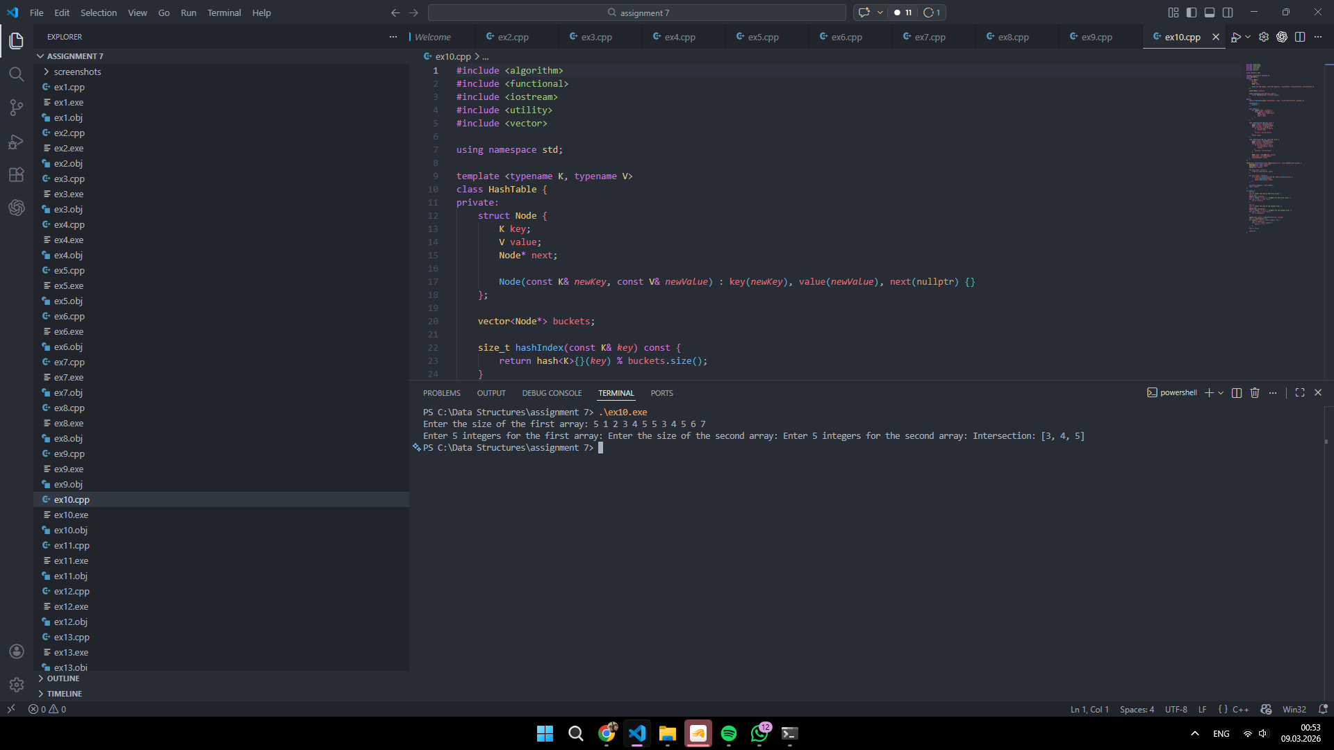
Exercise 11
Code (ex11.cpp):
#include <functional>
#include <iostream>
#include <utility>
#include <vector>

using namespace std;

template <typename K, typename V>
class HashTable {
private:
struct Node {
K key;
V value;
Node* next;

Node(const K& newKey, const V& newValue) : key(newKey), value(newValue), next(nullptr) {}
};

vector<Node*> buckets;

size_t hashIndex(const K& key) const {
return hash<K>{}(key) % buckets.size();
}

public:
explicit HashTable(size_t bucketCount = 211) : buckets(bucketCount, nullptr) {}

~HashTable() {
clear();
}

void clear() {
for (Node*& head : buckets) {
while (head != nullptr) {
Node* next = head->next;
delete head;
head = next;
}
}
}

bool contains(const K& key) const {
size_t index = hashIndex(key);
Node* current = buckets[index];
while (current != nullptr) {
if (current->key == key) {
return true;
}
current = current->next;
}
return false;
}

void insert(const K& key, const V& value) {
size_t index = hashIndex(key);
Node* current = buckets[index];
while (current != nullptr) {
if (current->key == key) {
current->value = value;
return;
}
current = current->next;
}

Node* node = new Node(key, value);
node->next = buckets[index];
buckets[index] = node;
}
};

bool hasZeroSumSubarray(const vector<int>& numbers) {
HashTable<int, bool> prefixSums;
prefixSums.insert(0, true);

int prefix = 0;
for (int number : numbers) {
prefix += number;
if (prefixSums.contains(prefix)) {
return true;
}
prefixSums.insert(prefix, true);
}

return false;
}

int main() {
int n;
cout << "Enter the number of integers: ";
cin >> n;

vector<int> numbers(n);
cout << "Enter " << n << " integers: ";
for (int i = 0; i < n; ++i) {
cin >> numbers[i];
}

cout << "Contains a zero-sum subarray: " << (hasZeroSumSubarray(numbers) ? "true" : "false") << '\n';
return 0;
}
Screenshot:
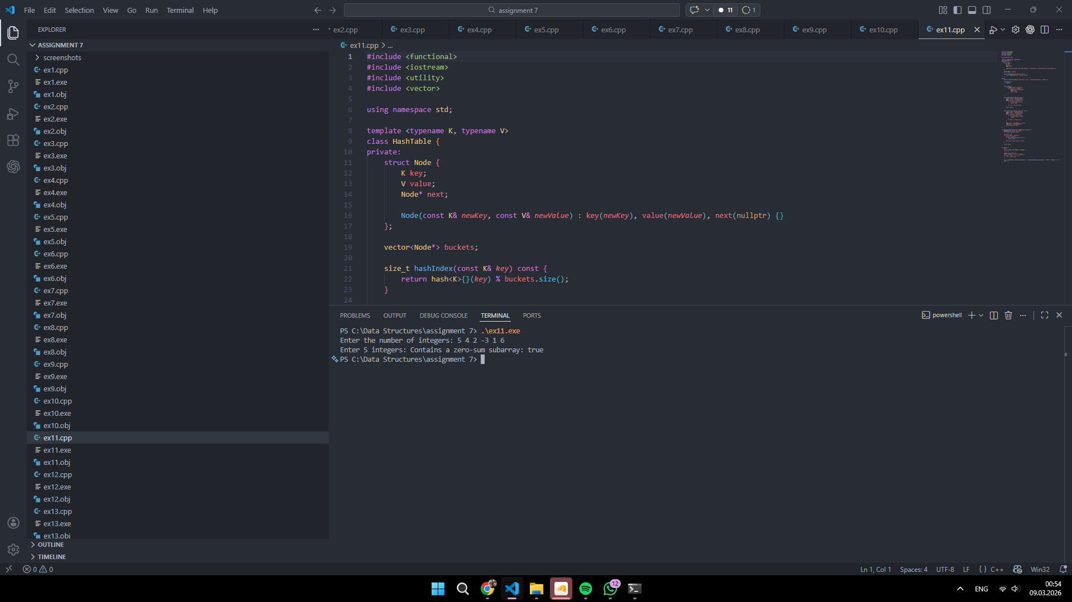
Exercise 12
Code (ex12.cpp):
#include <functional>
#include <iostream>
#include <utility>
#include <vector>

using namespace std;

template <typename K, typename V>
class HashTable {
private:
struct Node {
K key;
V value;
Node* next;

Node(const K& newKey, const V& newValue) : key(newKey), value(newValue), next(nullptr) {}
};

vector<Node*> buckets;

size_t hashIndex(const K& key) const {
return hash<K>{}(key) % buckets.size();
}

public:
explicit HashTable(size_t bucketCount = 211) : buckets(bucketCount, nullptr) {}

~HashTable() {
clear();
}

void clear() {
for (Node*& head : buckets) {
while (head != nullptr) {
Node* next = head->next;
delete head;
head = next;
}
}
}

bool contains(const K& key) const {
size_t index = hashIndex(key);
Node* current = buckets[index];
while (current != nullptr) {
if (current->key == key) {
return true;
}
current = current->next;
}
return false;
}

void insert(const K& key, const V& value) {
size_t index = hashIndex(key);
Node* current = buckets[index];
while (current != nullptr) {
if (current->key == key) {
current->value = value;
return;
}
current = current->next;
}

Node* node = new Node(key, value);
node->next = buckets[index];
buckets[index] = node;
}
};

int longestConsecutiveSequence(const vector<int>& numbers) {
HashTable<int, bool> values;
for (int number : numbers) {
values.insert(number, true);
}

int best = 0;
for (int number : numbers) {
if (values.contains(number - 1)) {
continue;
}

int length = 1;
while (values.contains(number + length)) {
++length;
}

if (length > best) {
best = length;
}
}

return best;
}

int main() {
int n;
cout << "Enter the number of integers: ";
cin >> n;

vector<int> numbers(n);
cout << "Enter " << n << " integers: ";
for (int i = 0; i < n; ++i) {
cin >> numbers[i];
}

cout << "Length of the longest consecutive sequence: " << longestConsecutiveSequence(numbers) << '\n';
return 0;
}
Screenshot:
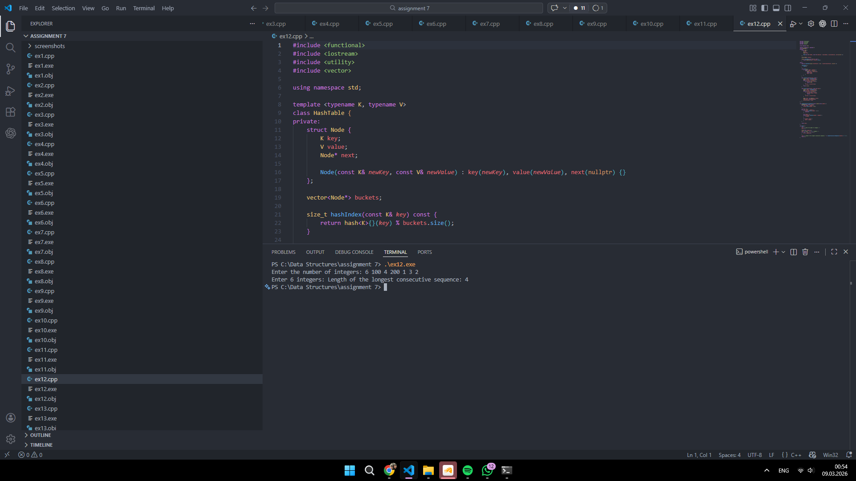
Exercise 13
Code (ex13.cpp):
#include <functional>
#include <iostream>
#include <string>
#include <utility>
#include <vector>

using namespace std;

template <typename K, typename V>
class HashTable {
private:
struct Node {
K key;
V value;
Node* next;

Node(const K& newKey, const V& newValue) : key(newKey), value(newValue), next(nullptr) {}
};

vector<Node*> buckets;

size_t hashIndex(const K& key) const {
return hash<K>{}(key) % buckets.size();
}

public:
explicit HashTable(size_t bucketCount = 211) : buckets(bucketCount, nullptr) {}

~HashTable() {
clear();
}

void clear() {
for (Node*& head : buckets) {
while (head != nullptr) {
Node* next = head->next;
delete head;
head = next;
}
}
}

V getOrDefault(const K& key, const V& defaultValue) const {
size_t index = hashIndex(key);
Node* current = buckets[index];
while (current != nullptr) {
if (current->key == key) {
return current->value;
}
current = current->next;
}
return defaultValue;
}

void insert(const K& key, const V& value) {
size_t index = hashIndex(key);
Node* current = buckets[index];
while (current != nullptr) {
if (current->key == key) {
current->value = value;
return;
}
current = current->next;
}

Node* node = new Node(key, value);
node->next = buckets[index];
buckets[index] = node;
}

vector<pair<K, V>> items() const {
vector<pair<K, V>> result;
for (Node* head : buckets) {
Node* current = head;
while (current != nullptr) {
result.push_back(make_pair(current->key, current->value));
current = current->next;
}
}
return result;
}
};

bool areAnagrams(const string& first, const string& second) {
if (first.length() != second.length()) {
return false;
}

HashTable<char, int> counts;
for (char ch : first) {
counts.insert(ch, counts.getOrDefault(ch, 0) + 1);
}
for (char ch : second) {
counts.insert(ch, counts.getOrDefault(ch, 0) - 1);
}

vector<pair<char, int>> items = counts.items();
for (const auto& item : items) {
if (item.second != 0) {
return false;
}
}
return true;
}

int main() {
string first;
string second;

cout << "Enter the first string without spaces: ";
cin >> first;
cout << "Enter the second string without spaces: ";
cin >> second;

cout << "Anagrams: " << (areAnagrams(first, second) ? "true" : "false") << '\n';
return 0;
}
Screenshot:
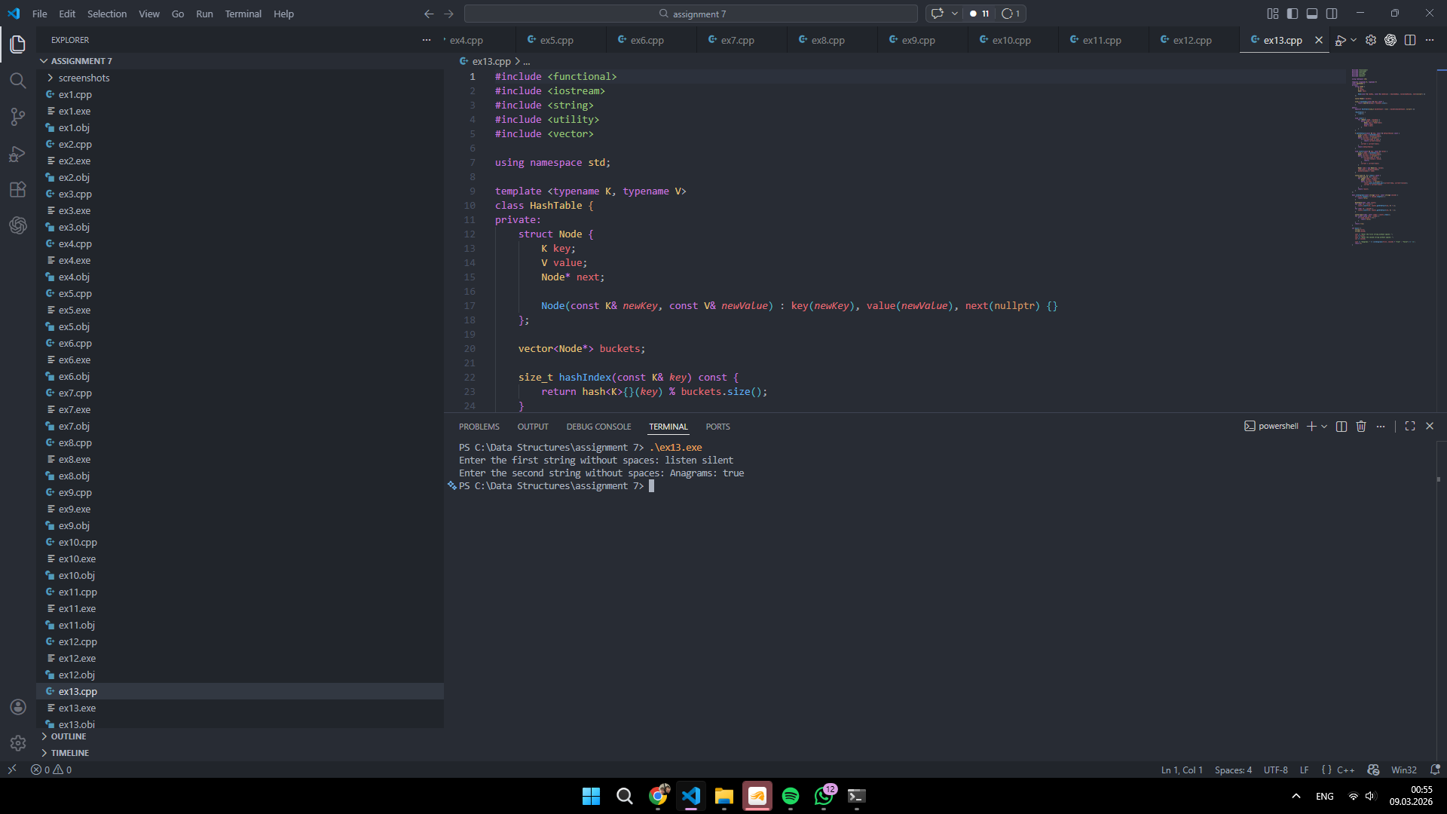
Exercise 14
Code (ex14.cpp):
#include <functional>
#include <iostream>
#include <utility>
#include <vector>

using namespace std;

template <typename K, typename V>
class HashTable {
private:
struct Node {
K key;
V value;
Node* next;

Node(const K& newKey, const V& newValue) : key(newKey), value(newValue), next(nullptr) {}
};

vector<Node*> buckets;

size_t hashIndex(const K& key) const {
return hash<K>{}(key) % buckets.size();
}

public:
explicit HashTable(size_t bucketCount = 211) : buckets(bucketCount, nullptr) {}

~HashTable() {
clear();
}

void clear() {
for (Node*& head : buckets) {
while (head != nullptr) {
Node* next = head->next;
delete head;
head = next;
}
}
}

V getOrDefault(const K& key, const V& defaultValue) const {
size_t index = hashIndex(key);
Node* current = buckets[index];
while (current != nullptr) {
if (current->key == key) {
return current->value;
}
current = current->next;
}
return defaultValue;
}

void insert(const K& key, const V& value) {
size_t index = hashIndex(key);
Node* current = buckets[index];
while (current != nullptr) {
if (current->key == key) {
current->value = value;
return;
}
current = current->next;
}

Node* node = new Node(key, value);
node->next = buckets[index];
buckets[index] = node;
}
};

int countPairsWithXor(const vector<int>& numbers, int targetXor) {
HashTable<int, int> frequencies;
int pairs = 0;

for (int number : numbers) {
int needed = number ^ targetXor;
pairs += frequencies.getOrDefault(needed, 0);
frequencies.insert(number, frequencies.getOrDefault(number, 0) + 1);
}

return pairs;
}

int main() {
int n;
cout << "Enter the number of integers: ";
cin >> n;

vector<int> numbers(n);
cout << "Enter " << n << " integers: ";
for (int i = 0; i < n; ++i) {
cin >> numbers[i];
}

int targetXor;
cout << "Enter the target XOR value: ";
cin >> targetXor;

cout << "Number of pairs: " << countPairsWithXor(numbers, targetXor) << '\n';
return 0;
}
Screenshot:
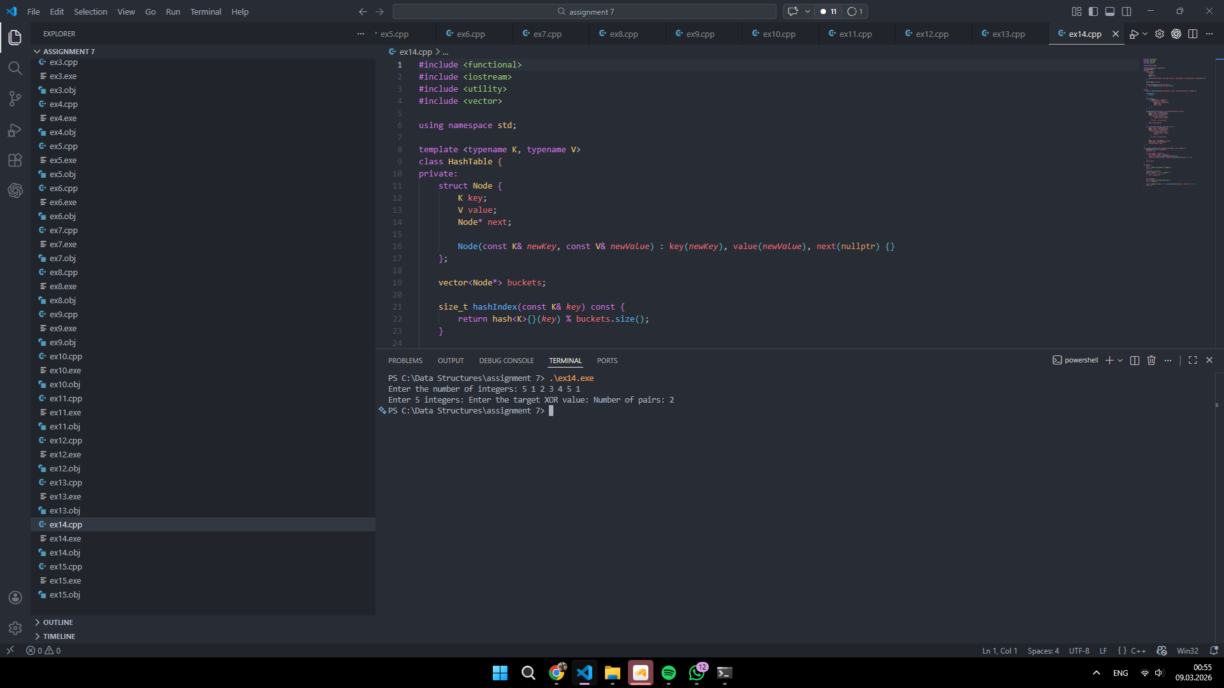
Exercise 15
Code (ex15.cpp):
#include <functional>
#include <iostream>
#include <string>
#include <utility>
#include <vector>

using namespace std;

template <typename K, typename V>
class HashTable {
private:
struct Node {
K key;
V value;
Node* next;

Node(const K& newKey, const V& newValue) : key(newKey), value(newValue), next(nullptr) {}
};

vector<Node*> buckets;

size_t hashIndex(const K& key) const {
return hash<K>{}(key) % buckets.size();
}

public:
explicit HashTable(size_t bucketCount = 211) : buckets(bucketCount, nullptr) {}

~HashTable() {
clear();
}

void clear() {
for (Node*& head : buckets) {
while (head != nullptr) {
Node* next = head->next;
delete head;
head = next;
}
}
}

bool contains(const K& key) const {
size_t index = hashIndex(key);
Node* current = buckets[index];
while (current != nullptr) {
if (current->key == key) {
return true;
}
current = current->next;
}
return false;
}

V getOrDefault(const K& key, const V& defaultValue) const {
size_t index = hashIndex(key);
Node* current = buckets[index];
while (current != nullptr) {
if (current->key == key) {
return current->value;
}
current = current->next;
}
return defaultValue;
}

void insert(const K& key, const V& value) {
size_t index = hashIndex(key);
Node* current = buckets[index];
while (current != nullptr) {
if (current->key == key) {
current->value = value;
return;
}
current = current->next;
}

Node* node = new Node(key, value);
node->next = buckets[index];
buckets[index] = node;
}

vector<pair<K, V>> items() const {
vector<pair<K, V>> result;
for (Node* head : buckets) {
Node* current = head;
while (current != nullptr) {
result.push_back(make_pair(current->key, current->value));
current = current->next;
}
}
return result;
}
};

vector<int> findAllAnagrams(const string& text, const string& pattern) {
vector<int> indices;
if (pattern.empty() || text.length() < pattern.length()) {
return indices;
}

HashTable<char, int> targetCount;
HashTable<char, int> windowCount;
for (char ch : pattern) {
targetCount.insert(ch, targetCount.getOrDefault(ch, 0) + 1);
}

vector<pair<char, int>> targetItems = targetCount.items();
int matchedKinds = 0;
int requiredKinds = static_cast<int>(targetItems.size());

for (size_t right = 0; right < text.length(); ++right) {
char incoming = text[right];
if (targetCount.contains(incoming)) {
int newValue = windowCount.getOrDefault(incoming, 0) + 1;
windowCount.insert(incoming, newValue);

int targetValue = targetCount.getOrDefault(incoming, 0);
if (newValue == targetValue) {
++matchedKinds;
} else if (newValue == targetValue + 1) {
--matchedKinds;
}
}

if (right >= pattern.length()) {
char outgoing = text[right - pattern.length()];
if (targetCount.contains(outgoing)) {
int currentValue = windowCount.getOrDefault(outgoing, 0);
int targetValue = targetCount.getOrDefault(outgoing, 0);
if (currentValue == targetValue) {
--matchedKinds;
} else if (currentValue == targetValue + 1) {
++matchedKinds;
}
windowCount.insert(outgoing, currentValue - 1);
}
}

if (right + 1 >= pattern.length() && matchedKinds == requiredKinds) {
indices.push_back(static_cast<int>(right + 1 - pattern.length()));
}
}

return indices;
}

int main() {
string text;
string pattern;

cout << "Enter the main string without spaces: ";
cin >> text;
cout << "Enter the pattern string without spaces: ";
cin >> pattern;

vector<int> indices = findAllAnagrams(text, pattern);
cout << "Starting indices: [";
for (size_t i = 0; i < indices.size(); ++i) {
cout << indices[i];
if (i + 1 != indices.size()) {
cout << ", ";
}
}
cout << "]\n";

return 0;
}
Screenshot:
